Experiment - 17

AIM ::
WAP to implement a moving banner in java using applet and threads.
Code ::

1. q17_MovingBanner.java

import java.applet.Applet;
import java.awt.*;

public class q17_MovingBanner extends Applet implements Runnable {
private String message = "Welcome to Java Programming!";
private int xPos = 100; // Initial position of the text
private int yPos = 50; // Y-coordinate of the text
private Thread thread;

@Override
public void init() {
thread = new Thread(this);
thread.start();
}

@Override
public void run() {
while (true) {
xPos -= 2; // Move the text to the left

// If the text moves completely off screen, reset its position
if (xPos < -getFontMetrics(getFont()).stringWidth(message)) {
xPos = getWidth();
}

repaint(); // Redraw the applet

try {
Thread.sleep(50); // Control the speed of movement
} catch (InterruptedException e) {
Thread.currentThread().interrupt();
}
}
}

@Override
public void paint(Graphics g) {
g.drawString(message, xPos, yPos);
}

@Override
public void stop() {
thread = null; // Stop the thread when applet is stopped
}
}

2. q17_MovingBanner.html

<html>
<body>
<applet code="q17_MovingBanner.class" width="400" height="150"></applet>
</body>
</html>
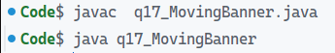
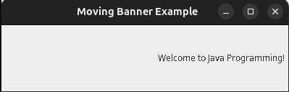
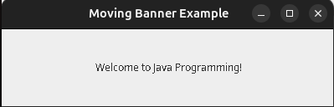
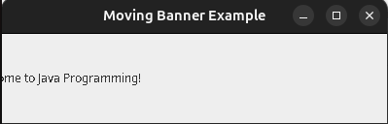
Output ::
Experiment - 16

AIM ::
WAP to implement a basic applet.
Code ::

1. q16_BasicApplet.java

import java.applet.Applet;
import java.awt.Graphics;

public class q16_BasicApplet extends Applet {
// Override the paint method to display the message
@Override
public void paint(Graphics g) {
// Display the message on the applet window
g.drawString("Hi, This is Amit Singhal", 50, 60);
}
}

2. q16_BasicApplet.html

<html>
<body>
<applet code="q16_BasicApplet.class" width="400" height="150"></applet>
</body>
</html>
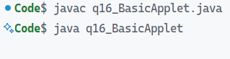
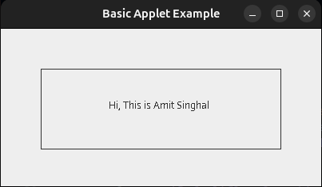
Output ::
Experiment - 18

AIM ::
WAP to call a frame using applet and awt.
Code ::

1. q18_AppletWithFrame.java

import java.applet.Applet;
import java.awt.*;

@SuppressWarnings("removal")
public class q18_AppletWithFrame extends Applet {

@Override
public void init() {
// Create a Frame
Frame myFrame = new Frame("Applet with Frame");

// Create a Label in the Frame
Label label = new Label("Hello, I am inside a Frame!");

// Set layout and add label
myFrame.setLayout(new FlowLayout());
myFrame.add(label);

// Set frame size and make it visible
myFrame.setSize(300, 200);
myFrame.setVisible(true);
}

@Override
public void paint(Graphics g) {
g.drawString("This is an Applet!", 50, 50);
}
}

2. q18_AppletWithFrame.html

<html>
<body>
<applet code="q18_AppletWithFrame.class" width="400" height="250"></applet>
</body>
</html>
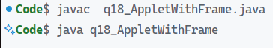
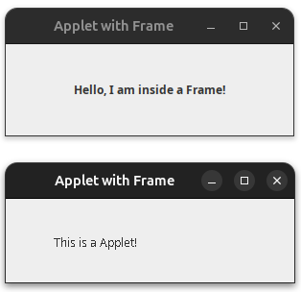
Output ::
Experiment - 21

AIM ::
WAP to implement a student java bean and access it using another java file.
Code ::

1. Student.java

import java.io.Serializable;

public class Student implements Serializable {
private static final long serialVersionUID = 1L;
private int id; private int age;
private String name;

public Student() {}
public Student(int id, String name, int age) {
this.id = id;
this.name = name;
this.age = age;
}
public int getId() { return id; }
public void setId(int id) { this.id = id; }

public String getName() { return name; }
public void setName(String name) { this.name = name; }

public int getAge() { return age; }
public void setAge(int age) {
if (age > 0) {
this.age = age;
} else {
System.out.println("Age must be positive.");
}
}

@Override
public String toString() {
return "Student [ID=" + id + ", Name=" + name + ", Age=" + age + "]";
}
}

2. StudentTest.java

public class StudentTest {
public static void main(String[] args) {
// Creating a Student object using no-arg constructor
Student student = new Student();
student.setId(101);
student.setName("Alice");
student.setAge(20);

// Displaying student details
System.out.println("Student ID: " + student.getId());
System.out.println("Student Name: " + student.getName());
System.out.println("Student Age: " + student.getAge());
System.out.println("The Student 1 Is : " + student);

// Creating another Student object using parameterized constructor
Student student2 = new Student(102, "Bob", 22);
System.out.println("The Student 2 Is : " + student2);
}
}
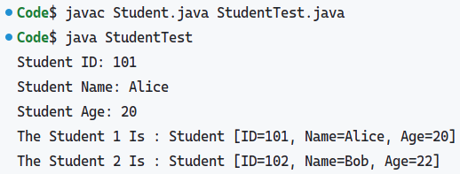Output ::
Experiment - 22

AIM ::
WAP to implement an employee java bean and access it using another java file.
Code ::

1. Employee.java

import java.io.Serializable;

public class Employee implements Serializable {
private static final long serialVersionUID = 1L;
private int empId;
private double salary;
private String empName;

public Employee() {}

public int getEmpId() { return empId; }
public void setEmpId(int empId) { this.empId = empId; }

public String getEmpName() { return empName; }
public void setEmpName(String empName) { this.empName = empName; }

public double getSalary() { return salary; }
public void setSalary(double salary) {
if (salary > 0) {
this.salary = salary;
} else {
System.out.println("Salary must be positive.");
}
}

@Override
public String toString() {
return "Employee [ID=" + empId + ", Name=" + empName + ", Salary=" + salary + "]";
}
}

2. EmployeeTest.java

public class EmployeeTest {
public static void main(String[] args) {
// Creating an Employee Bean using the no-arg constructor
Employee emp = new Employee();

// Setting properties using setter methods with random values
emp.setEmpId(2034);
emp.setEmpName("Lena Rivers");
emp.setSalary(78560.50);

// Getting properties using getter methods
System.out.println("Employee ID: " + emp.getEmpId());
System.out.println("Employee Name: " + emp.getEmpName());
System.out.println("Employee Salary: $" + emp.getSalary());
System.out.println("The Employee Details Are : " + emp);
}
}
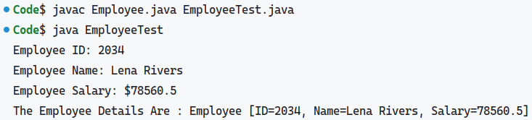
Output ::
Experiment - 23

AIM ::
Write a servlet using Web-Servlet to handle GET request and display HTML response
Code ::

HelloServlet.java
import java.io.*;
import jakarta.servlet.*;
import jakarta.servlet.http.*;
import jakarta.servlet.annotation.*;

@WebServlet("/hello")
public class HelloServlet extends HttpServlet {
private static final long serialVersionUID = 1L;

protected void doGet(HttpServletRequest request , HttpServletResponse response)
throws ServletException, IOException {
response.setContentType("text/html");
PrintWriter out = response.getWriter();
out.println("<!DOCTYPE html><html lang='en'><head>");

out.println("<meta charset='UTF-8'><meta name='viewport' content='width=device-width, initial-scale=1.0'>");
out.println("<title>Document</title></head><body>");
out.println("<h2>Hello, World! Welcome to Servlet Programming.</h2>");
out.println("<p>Created By : Amit Singhal , 11614802722</p></body></html>");
}
}

pom.xml (Dependency Section Snippet)
<dependency>
<groupId>jakarta.servlet</groupId>
<artifactId>jakarta.servlet-api</artifactId>
<version>5.0.0</version>
<scope>provided</scope>
</dependency>
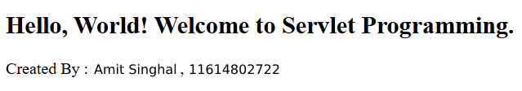
Output ::
Experiment - 24

AIM ::
Write a Java Program to create a Chat Server
Code ::

1. ChatServer.java
import java.io.*;
import java.net.*;
import java.util.*;

public class ChatServer {
// List to hold all connected client handlers
private static final List<ClientHandler> clients = new ArrayList<>();

public static void main(String[] args) {
int port = 12345; // The server port
try (ServerSocket serverSocket = new ServerSocket(port)) {
System.out.println("Chat Server started on port " + port);
// Continuously accept client connections
while (true) {
Socket clientSocket = serverSocket.accept();
System.out.println("New client connected: " + clientSocket.getInetAddress());
// Create a new client handler to manage the client's messages
ClientHandler clientHandler = new ClientHandler(clientSocket);
clients.add(clientHandler);
// Start a new thread for the client
new Thread(clientHandler).start();
}
} catch (IOException e) {
e.printStackTrace();
}
}

// Method to broadcast messages to all clients
public static void broadcastMessage(String message, ClientHandler sender) {
for (ClientHandler client : clients) {
// Don't send the message to the sender
if (client != sender) {
client.sendMessage(message);
}
}
}

// Inner class to handle each client's communication
private static class ClientHandler implements Runnable {
private Socket socket;
private PrintWriter out;
private BufferedReader in;
private String clientName;

public ClientHandler(Socket socket) {
this.socket = socket;
try {
// Setup input and output streams
in = new BufferedReader(new InputStreamReader(socket.getInputStream()));
out = new PrintWriter(socket.getOutputStream(), true);
// Get the client's name
out.println("Enter your name: ");
clientName = in.readLine();
out.println("Welcome to the chat, " + clientName + "!");
} catch (IOException e) {
e.printStackTrace();
}
}

// Method to send message to the client
public void sendMessage(String message) {
out.println(message);
}

@Override
public void run() {
String message;
try {
while ((message = in.readLine()) != null) {
if (message.equalsIgnoreCase("exit")) {
break;
}
// Broadcast the message to all clients
System.out.println(clientName + ": " + message);
ChatServer.broadcastMessage(clientName + ": " + message, this);
}
} catch (IOException e) {
e.printStackTrace();
} finally {
try {
// Remove the client from the list of active clients
clients.remove(this);
socket.close();
System.out.println(clientName + " has disconnected.");
} catch (IOException e) {
e.printStackTrace();
}
}
}
}
}

2. ChatClient.java
import java.io.*;
import java.net.*;

public class ChatClient {
private static PrintWriter out;
private static BufferedReader in;
private static BufferedReader userInput;

public static void main(String[] args) {
String serverAddress = "localhost"; // The server address (localhost for local machine)
int port = 12345; // The server port

try (Socket socket = new Socket(serverAddress, port)) {
// Setup input and output streams
in = new BufferedReader(new InputStreamReader(socket.getInputStream()));
out = new PrintWriter(socket.getOutputStream(), true);
userInput = new BufferedReader(new InputStreamReader(System.in));

// Read welcome message from the server
String serverMessage = in.readLine();
System.out.println(serverMessage);

// Get the client's name from the user
String name = userInput.readLine();
out.println(name);

// Listen for server messages and print them to the console
new Thread(new ServerListener()).start();

// Send messages to the server
String message;
while (true) {
message = userInput.readLine();
out.println(message);
if (message.equalsIgnoreCase("exit")) {
break;
}
}
} catch (IOException e) {
e.printStackTrace();
}
}

// Inner class to listen for messages from the server
private static class ServerListener implements Runnable {
@Override
public void run() {
String message;
try {
while ((message = in.readLine()) != null) {
System.out.println(message);
}
} catch (IOException e) {
e.printStackTrace();
}
}
}
}
Output ::
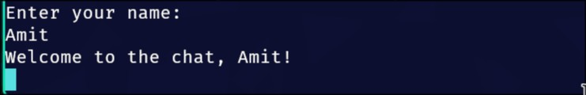
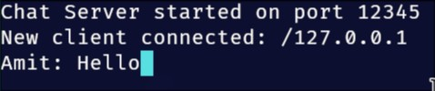
Experiment - 25

AIM ::
Write a Java Program to Showcase the use of Listeners
Code ::

1. SwingListenersExample.java
import javax.swing.*;
import java.awt.*;
import java.awt.event.*;

public class SwingListenersExample {
public static void main(String[] args) {
// Create a frame for the GUI
JFrame frame = new JFrame("Swing Listeners Example");
frame.setSize(400, 300);
frame.setDefaultCloseOperation(JFrame.EXIT_ON_CLOSE);

// Create a panel to hold components
JPanel panel = new JPanel();
panel.setLayout(new FlowLayout());

// Create a button and add an ActionListener
JButton button = new JButton("Click Me");
button.addActionListener(new ActionListener() {
@Override
public void actionPerformed(ActionEvent e) {
JOptionPane.showMessageDialog(frame, "Button clicked!");
}
});

// Create a text field and add a KeyListener
JTextField textField = new JTextField(20);
textField.addKeyListener(new KeyAdapter() {
@Override
public void keyTyped(KeyEvent e) {
// Display the key that is typed
char c = e.getKeyChar();
System.out.println("Key Typed: " + c);
}
});

// Create a label and add a MouseListener
JLabel label = new JLabel("Click me!");
label.addMouseListener(new MouseAdapter() {
@Override
public void mouseClicked(MouseEvent e) {
JOptionPane.showMessageDialog(frame, "Label clicked!");
}
});

// Add the components to the panel
panel.add(button);
panel.add(textField);
panel.add(label);

// Add the panel to the frame
frame.add(panel);

// Set the frame to be visible
frame.setVisible(true);
}
}
Output ::

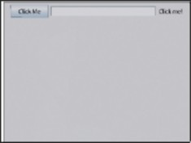
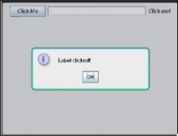
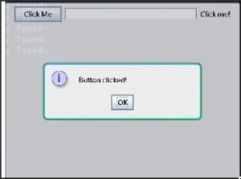
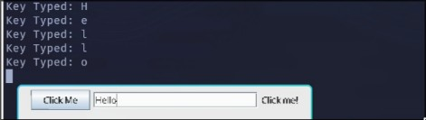
Experiment - 26

AIM ::
Write a simple Swing Program in java.
Code ::

1. SimpleSwingProgram.java
import javax.swing.*;
import java.awt.*;
import java.awt.event.*;

public class SimpleSwingProgram {
public static void main(String[] args) {
// Create a new JFrame (main window)
JFrame frame = new JFrame("Simple Swing Program");

// Set the layout for the frame
frame.setLayout(new FlowLayout());

// Create a label
JLabel label = new JLabel("Enter your name:");

// Create a text field for user input
JTextField textField = new JTextField(20);

// Create a button that will trigger an action
JButton button = new JButton("Submit");

// ActionListener for the button
button.addActionListener(new ActionListener() {
@Override
public void actionPerformed(ActionEvent e) {
String name = textField.getText();
label.setText("Hello, " + name + "!");
}
});

// Add the components to the frame
frame.add(label);
frame.add(textField);
frame.add(button);

// Set frame properties
frame.setSize(300, 150); // Set the size of the window
frame.setDefaultCloseOperation(JFrame.EXIT_ON_CLOSE); // Close the application when the window is closed
frame.setVisible(true);
}
}

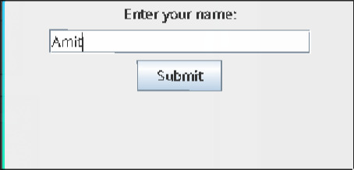
Output ::
Experiment - 27

AIM ::
Write a Java Program to showcase the use of JSP
Code ::

1. index.html
<html>
<head>
<title>Simple JSP Example</title>
</head>
<body>
<h2>Welcome to JSP Example</h2>
<form action="greet.jsp" method="post">
Enter your name: <input type="text" name="username" />
<input type="submit" value="Greet Me" />
</form>
</body>
</html>

2. greet.jsp
<!DOCTYPE html>
<html>
<head>
<title>Greeting Page</title>
</head>
<body>
<h2>Hello, <%= request.getParameter("username") %>!</h2>
<p>Welcome to the JSP World!</p>
<a href="index.jsp">Go Back</a>
</body>
</html>
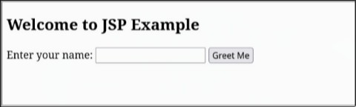
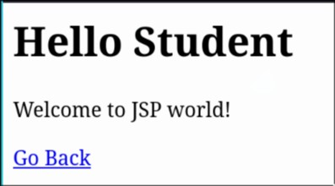
Output ::
Experiment - 19

AIM ::
Write a Java Program to showcase the use of Layout
Manager
Code ::

LayoutManagersExample.java
import java.awt.*;
import javax.swing.*;

public class LayoutManagersExample {
public static void main(String[] args) {
// Create a new JFrame (main window)
JFrame frame = new JFrame("Layout Manager Example");
frame.setDefaultCloseOperation(JFrame.EXIT_ON_CLOSE);
frame.setSize(400, 200); // Set the size of the window

// Create a panel with FlowLayout
JPanel flowPanel = new JPanel(new FlowLayout());
flowPanel.setBackground(Color.LIGHT_GRAY); // Set background color for the panel
flowPanel.add(new JButton("Button 1"));
flowPanel.add(new JButton("Button 2"));
flowPanel.add(new JButton("Button 3"));

// Create a panel with BorderLayout
JPanel borderPanel = new JPanel(new BorderLayout());
borderPanel.setBackground(Color.CYAN);
borderPanel.add(new JButton("North Button"), BorderLayout.NORTH);
borderPanel.add(new JButton("South Button"), BorderLayout.SOUTH);
borderPanel.add(new JButton("East Button"), BorderLayout.EAST);
borderPanel.add(new JButton("West Button"), BorderLayout.WEST);
borderPanel.add(new JButton("Center Button"), BorderLayout.CENTER);

// Use BorderLayout for the main frame
frame.setLayout(new BorderLayout());

// Add FlowLayout panel at the top
frame.add(flowPanel, BorderLayout.NORTH);

// Add BorderLayout panel in the center
frame.add(borderPanel, BorderLayout.CENTER);

// Make the frame visible
frame.setVisible(true);
}
}
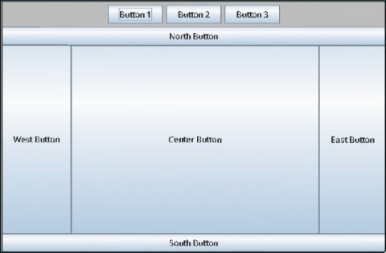
Output ::
Experiment - 20

AIM ::
Write a Java Program to represent a Human Skull
Code ::

HumanSkullDrawing.java
import javax.swing.*;
import java.awt.*;

public class HumanSkullDrawing extends JPanel {

@Override
protected void paintComponent(Graphics g) {
super.paintComponent(g);

// Cast Graphics to Graphics2D for better control over drawing
Graphics2D g2d = (Graphics2D) g;

// Anti-aliasing for smoother curves
g2d.setRenderingHint(RenderingHints.KEY_ANTIALIASING, RenderingHints.VALUE_ANTIALIAS_ON);

// Draw skull outline (main head shape)
g2d.setColor(new Color(255, 255, 255)); // Skull color: white
g2d.fillOval(100, 50, 200, 250); // Oval for the skull

// Draw eyes (two black circles)
g2d.setColor(Color.BLACK);
g2d.fillOval(145, 120, 35, 50); // Left eye
g2d.fillOval(220, 120, 35, 50); // Right eye

// Draw nose (triangle-like shape)
int[] xPoints = {190, 210, 200}; // X coordinates for the triangle
int[] yPoints = {180, 180, 220}; // Y coordinates for the triangle
g2d.fillPolygon(xPoints, yPoints, 3); // Nose is a simple triangle

// Draw mouth (curved shape)
g2d.setColor(Color.BLACK);
g2d.drawArc(150, 220, 100, 50, 0, -180); // Mouth using arc

// Draw teeth (simplified)
g2d.setColor(Color.WHITE);
g2d.fillRect(160, 230, 20, 30); // Left tooth
g2d.fillRect(180, 230, 20, 30); // Second tooth
g2d.fillRect(200, 230, 20, 30); // Third tooth
g2d.fillRect(220, 230, 20, 30); // Fourth tooth
g2d.fillRect(240, 230, 20, 30); // Fifth tooth

// Draw cracks on the skull (optional for effect)
g2d.setColor(Color.GRAY);
g2d.drawLine(160, 80, 220, 110); // Example crack
g2d.drawLine(230, 100, 170, 150); // Another crack
}

public static void main(String[] args) {
// Create a frame to display the panel
JFrame frame = new JFrame("Human Skull Drawing");
HumanSkullDrawing skullPanel = new HumanSkullDrawing();
frame.setDefaultCloseOperation(JFrame.EXIT_ON_CLOSE);
frame.setSize(400, 400); // Set the frame size
frame.add(skullPanel); // Add the drawing panel to the frame
frame.setVisible(true); // Make the frame visible
}
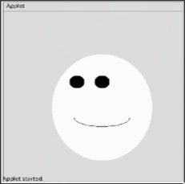
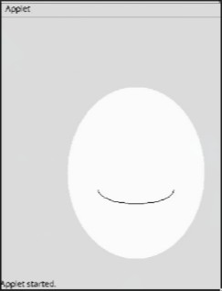
}
Output ::
Experiment - 28

AIM ::
Write a Java Program to showcase the use of a Servlet
Code ::

1. HelloWorldServlet.java
import java.io.*;
import javax.servlet.*;
import javax.servlet.http.*;

public class HelloWorldServlet extends HttpServlet {
// Overriding the doGet method to handle HTTP GET requests
@Override
protected void doGet(HttpServletRequest request, HttpServletResponse response)
throws ServletException, IOException {
// Setting the response content type
response.setContentType("text/html");

// Writing the response message
PrintWriter out = response.getWriter();
out.println("<html><body>");
out.println("<h1>Hello, World!</h1>");
out.println("</body></html>");
}
}

2. web.xml
<?xml version="1.0" encoding="UTF-8"?>
<web-app xmlns="http://java.sun.com/xml/ns/javaee"
xmlns:xsi="http://www.w3.org/2001/XMLSchema-instance"
xsi:schemaLocation="http://java.sun.com/xml/ns/javaee
http://java.sun.com/xml/ns/javaee/web-app_3_0.xsd"
version="3.0">

<servlet>
<servlet-name>HelloWorldServlet</servlet-name>
<servlet-class>HelloWorldServlet</servlet-class>
</servlet>

<servlet-mapping>
<servlet-name>HelloWorldServlet</servlet-name>
<url-pattern>/hello</url-pattern>
</servlet-mapping>

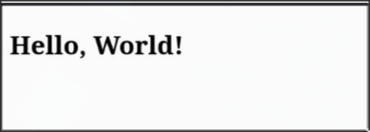
</web-app>
Output ::

